Annex 2 to the tender documentation

technical specification of the subject of the public contract

Article 1. Identification of the public contract and of the participant
Name of public contract: | Delivery of production lines
Type of tender: | public contract outside the regime of Act No. 134/2016 Coll., on public procurement (hereinafter referred to as "ZZVZ")
Type of public contract: | supplies

Name of subscriber: | Click here and enter the text.
Headquarters of the participant: | Click here and enter the text.
Point of contact: | Click here and enter the text.
ID: | Click here and enter the text.
This document shall be signed solely by the person authorised to represent the tenderer in the tender procedure.

Article 2. Technical specification of the subject of the public contract
This document sets out the minimum required technical parameters of the subject of the public contract - new production technology - Tube Welding Line - 2 units - Line I and Line II (hereinafter referred to as "subject of the public contract" or "equipment"). In case of ambiguity regarding the fulfilment of a certain parameter, the contracting authority may require the participant to submit product data sheets prepared by the manufacturer of the offered equipment (datasheets) or samples or models of the equipment in order to clarify the tender within the meaning of Section 46(1) of the ZZVZ.

The capacity, quality and technical parameters and requirements for the subject of the public contract, as well as the values specified for these parameters, are set as the minimum permissible. Bidders may therefore offer equipment that will have better parameters and features for the functionalities required by the Contracting Authority.

Article 3. Equipment offered by the participant
For each listed item (row) in the table, the bidder shall indicate the specific technical parameters of the equipment offered or, for non-quantifiable requirements, indicate YES/NO, i.e. whether or not the equipment meets the requirement. In addition, the tenderer shall indicate the manufacturer and the type designation of the equipment offered.
In order for a tender to be considered and further evaluated, the tenderer must meet all the technical parameters of the equipment required by the contracting authority.
Tube Welding Line (Tube Welding Line):
Line I:
Minimum technical parameters required by the client: |  | Technical parameters offered by the bidder or YES/NO - as specified below:
Tube diameter | 25-90 mm | Click and enter the value of the parameter
Square | 20x20 - 70x70 mm | Click and enter the value of the parameter
Rectangle | 25x15 - 100x40 mm | Click and enter the value of the parameter
The strength of the wall | 1-4 mm | Click and enter the value of the parameter
Production line speed (evaluation criterion) | up to 140 m/min. | Click and enter the value of the parameter
Profile length | 4000-14500 mm | Click and enter the value of the parameter
Input material | up to 1000 MPa. | Click and enter the value of the parameter
Tube diameter tolerance  (evaluation criterion) | +/- 0.1mm | Click and enter the value of the parameter
Tube length tolerance | +/- 1.5mm | Click and enter the value of the parameter
Flatness | 1 mm/m | Click and enter the value of the parameter
Standard: DIN EN 10219 |  | Click and indicate YES/NO.

Production mix and production speeds achieved:
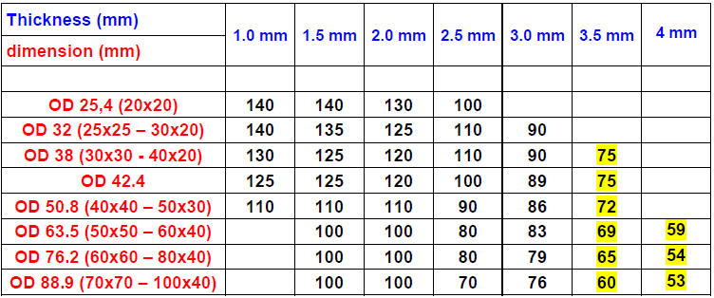
Equipment manufacturer | Click or tap here to enter the text.
Type designation of the device | Click or tap here to enter the text.

Line II..:
Minimum technical parameters required by the client: |  | Technical parameters offered by the bidder or YES/NO - as specified below:
Tube diameter | 12-63.5 mm | Click and enter the value of the parameter
Square | 12x12 - 50x50 mm | Click and enter the value of the parameter
Rectangle | 10x15 - 60x40 mm | Click and enter the value of the parameter
The strength of the wall | 0.8-3.5 mm | Click and enter the value of the parameter
Production line speed (evaluation criterion) | up to 140 m/min. | Click and enter the value of the parameter
Profile length | 4000-14500 mm | Click and enter the value of the parameter
Input material | up to 1000 MPa. | Click and enter the value of the parameter
Tube diameter tolerance  (evaluation criterion) | +/- 0.1 mm | Click and enter the value of the parameter
Tube length tolerance | +/- 1.5 mm | Click and enter the value of the parameter
Flatness | 1 mm/m | Click and enter the value of the parameter
Standard: DIN EN 10219 |  | Click and indicate YES/NO.

Production mix and production speeds achieved:
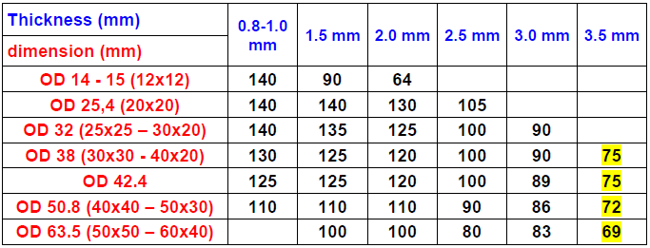
Equipment manufacturer | Click or tap here to enter the text.
Type designation of the device | Click or tap here to enter the text.

In site On date
Name, function, signature

